The Nautilus DevOps team is strategizing the migration of a portion of their infrastructure to the AWS cloud. Recognizing the scale of this undertaking, they have opted to approach the migration in incremental steps rather than as a single massive transition.
For this task, create one subnet named devops-subnet under default VPC.

Use below given AWS Credentials: (You can run the showcreds command on aws-client host to retrieve these credentials)
Console URL | https://480470673558.signin.aws.amazon.com/console?region=us-east-1
Username | kk_labs_user_246085
Password | Auz5Z3RGlV@E
Start Time | Mon Dec 01 01:41:23 UTC 2025
End Time | Mon Dec 01 02:41:23 UTC 2025
Notes:
- Create the resources only in us-east-1 region.
- To display or hide the terminal of the AWS client machine, you can use the expand toggle button as shown below:
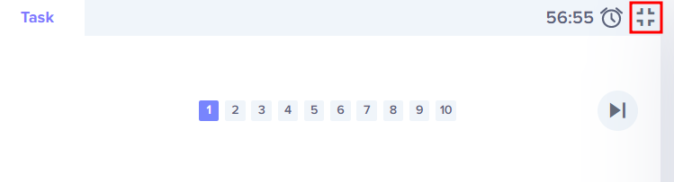

Solutions:-

Make sure exiting subnet not over lapping IPv4 CIDR range. For this please list out all ip range then create new one.

🛠 Steps to Create devops-subnet in Default VPC

Option 1: Using AWS Management Console
- Log in to the AWS Console → Navigate to VPC service.
- Under Subnets, click Create subnet.
- Select the default VPC (it’s automatically created in each AWS region).
- Provide details:
  - Name tag: devops-subnet
  - VPC ID: Select the default VPC
  - Availability Zone: Choose one (e.g., ap-south-1a for Mumbai region)
  - IPv4 CIDR block: Example 10.0.1.0/24 (ensure it doesn’t overlap with existing subnets in the default VPC)
- Click Create subnet.

